***EVENT REPORT*

*Technical Paper Presentation*

*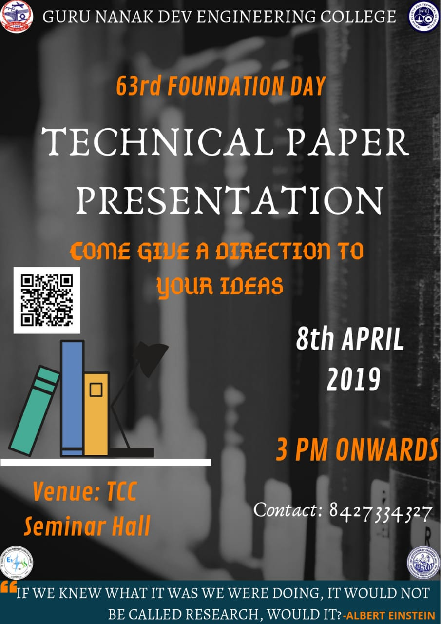***A Presentation based technical event “TECHNICAL PAPER PRESENTATION” was organised by INDIAN SOCIETY FOR TECHNICAL EDUCATION (ISTE) in eve of Foundation Day on 8th April’19 in Testing and Consultancy Seminar Hall.**

The event was of one round – The Presentation Round.

The event was mainly organised to test and improve the Presentation skills among students. Top three students were awarded for their excel performance.

In this event the students were provided different topics according to their, for preparing a presentation and represent it in front of panel of three judges from local chapter.

Some topics provided to the students are - Geo Textile, U-Boot Voided Sub technology, Virtual Reality & Augmented Reality, Building Information Modelling, Internet of Things and more.

The students were provided 8 minutes to represent their presentation and 2 minutes were provided for conclusion. Switching language during presentation was prohibited, the students disobeying these code was to be disqualified.

The judgement for the event was done in scale of 10 on the basis of content, presentation style, clarity and organisation.

The students involved in organising the event were –

|  |  |  |  |
| --- | --- | --- | --- |
| **Name** | **Branch** | **Year** | **University Roll Number** |
| Shubhendra Kumar | CE | 2nd Year | 1706310 |
| Harmanjot Kaur | ECE | 2nd Year | 1706726 |
| Dilnish Kaur Bagga | ECE | 2nd Year | 1706721 |
| Shubhangi Aryan | ECE | 2nd Year | 1706782 |
| Kanwardeep Singh | IT | 4th Year | 1507934 |
| Mannoor Kaur Dhingra | IT | 4th Year | 1507942 |
| Nikita Gulati | CSE | 4th Year | 1507630 |
| Kajal Trehan | CSE | 4th Year | 1507602 |
| Jagmeet Singh | ECE | 2nd Year | 1706728 |

The participants of the event -

|  |  |  |  |  |
| --- | --- | --- | --- | --- |
| **Name** | **Branch** | **Year** | **University Roll Number** | **Phone Number** |
| Kavleen Kour | CSE | 2nd Year | 1706457 | 7042404646 |
| Bhavyta Passi | EE | 4th Year | 1507706 | 7986117700 |
| Anmol Puri | CE | 2nd Year | 1714150 | 8360169179 |
| Pradeep Singh | ME | 2nd Year | 1607451 | 9478020789 |
| Karanvir | ME | 3rd Year | 1707132 | 9478849561 |
| Gursimran Singh | EE | 4th Year | 1507719 | 9501550906 |
| Harsimranejet Singh | EE | 4th Year | 1507725 | 8591926187 |

Winners of the event were-

|  |  |  |  |  |
| --- | --- | --- | --- | --- |
| **Postion** | **Name** | **Branch** | **Year** | **University Roll Number** |
| **1st** | Kavleen Kour | CSE | 2nd Year | 1706457 |
| **2nd** | Bhavyta Passi | EE | 4th Year | 1507706 |
| **3rd** | Anmol Puri | CE | 2nd Year | 1714150 |

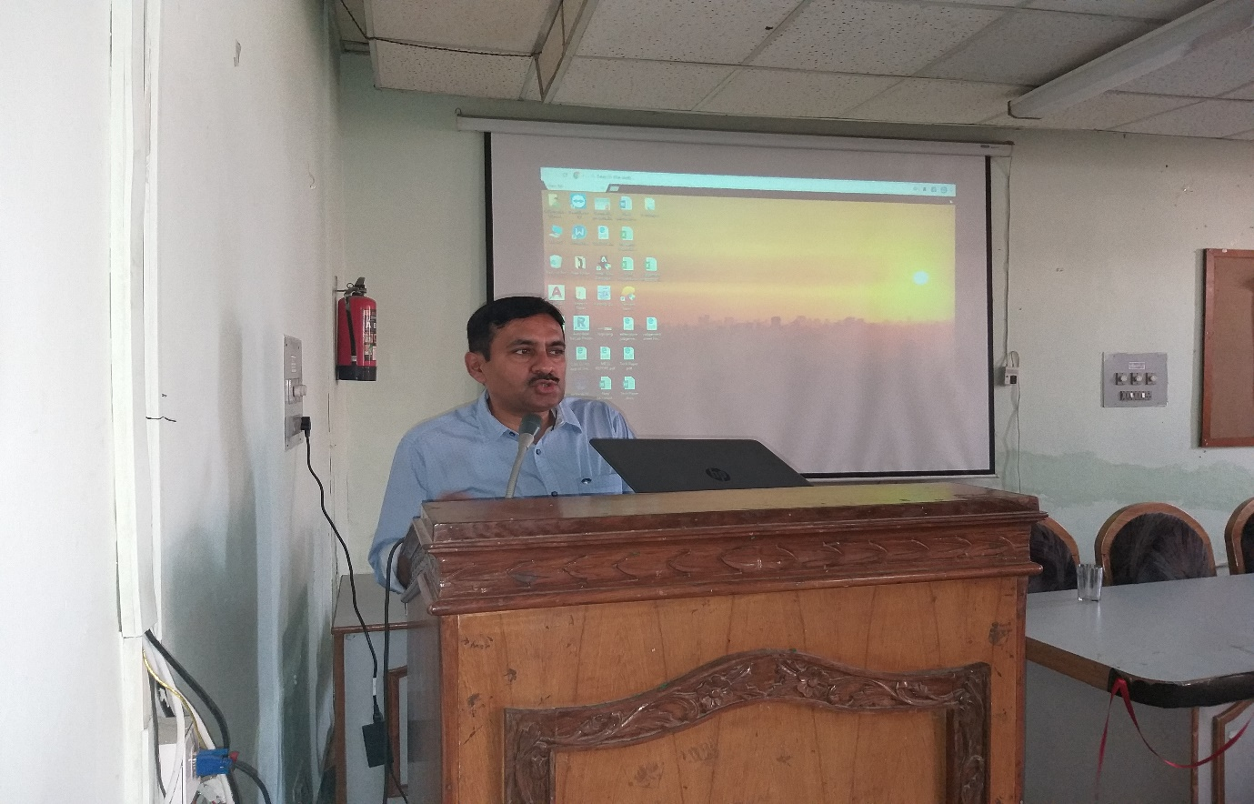Some gimples from the event-

